حدد أنواع اللحوم التالية

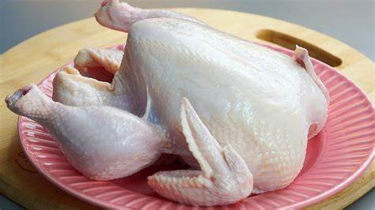

رتب خطوات تجميد اللحوم الصحيحه



